|  |  |  |  |  |  |  |  |  |
| --- | --- | --- | --- | --- | --- | --- | --- | --- |
|  |  | **Session Understanding Document** | | | | | <client logo> | |
|  |  |
|  |
|  |
|  |  |
|  |  |  |  |  |  |  |  |  |
|  | *Document Name* | *Session Understanding Document Hazard Assessment Risk Register* |  |  |  |  |  |  |
|  | *Version No.* | *1.0* |  |  |  |  |  |  |
|  | *Author* | *KT (Knowledge Transfer) Capability* |  |  |  |  |  |  |
|  | *Owner* | *ricardo.piquero.jr, faye.e.mendoza, winston.a.sarra, mark.noel.o.delica, maycell.t.see.bok* |  |  |  |  |  |  |
|  | *Purpose* | *The following template is* *provided to create System Understanding Documents* |  |  |  |  |  |  |
|  | *To be used by* | *Internal – Knowledge Recipients from Delivery Team* |  |  |  |  |  |  |
|  | *Remarks* |  |  |  |  |  |  |  |
|  |  |  |  |  |  |  |  |  |
|  | ***Instructions*** |  |  |  |  |  |  |  |
|  | Follow the Instructions provided below in <>. Delete the commentary before saving the document. | | | |  |  |  |  |
|  |  | | | | | |  |  |
|  |  |  |  |  |  |  |  |  |
|  |  |  |  |  |  |  |  |  |
|  | Framework | AO Start-Up 3.1 |  |  |  |  |  |  |
|  | Track | People |  |  |  |  |  |  |
|  | Process | Transfer Knowledge |  |  |  |  |  |  |
|  |  |  |  |  |  |  |  |  |

|  |  |
| --- | --- |
| Document Version: | 1.0 |
| Document Date: | 7/25/23 |
| Author: | Ricardo Jr. Piquero |
| SME Name / Organization: | Jin, Jiangshan; Wang, Shuang; Liu, Shi |
| SME contact details (email/phone): | [jiangshan.jin@accenture.com](mailto:jiangshan.jin@accenture.com), shuang.f.wang@accenture.com, shi.b.liu@accenture.com |
| Knowledge recipients (Name / email / phone) | ricardo.piquero.jr, faye.e.mendoza, winston.a.sarra, mark.noel.o.delica, maycell.t.see.bok |

|  |  |  |  |  |
| --- | --- | --- | --- | --- |
| **Version History** | | | | |
| **Version** | **Date** | **Author** | **Reviewer** | **Description** |
| 1.0 | 07/25/23 | ricardo.piquero.jr |  | N/A |
|  |  |  |  |  |
|  |  |  |  |  |
|  |  |  |  |  |
|  |  |  |  |  |
|  |  |  |  |  |

Table of Contents

1. Summary & Scope 4

*1.1* *Audience* 4

*1.2 Missing Information* 4

*1.3 Related Documentation* 4

2. Business Function 5

3. Application & Functional Architecture 6

4. Infrastructure – Hardware / Software 7

5. Data Architecture 8

6. Design Documents (HLD / LLD) 9

7. Technical Environment 10

8. Application Maintenance Process & Procedures 11

9. Application Overview 12

10. Overview of Interfaces and Interfacing Applications 13

11. User Management 14

12. Backup and Recovery 15

13. Data Maintenance 17

14. Release Management 18

15. Deployment 19

16. Prospective Automation Opportunities 20

17. Appendix 21

17.1. Incident, Defect, Problem Log 21

17.2. Audio Recordings 21

17.3. Documentation 21

18. Q&A log 22

# Summary & Scope

## *Audience*

* PowerApps PODs ITI
  + *ricardo.piquero.jr*
  + *faye.e.mendoza*
  + *winston.a.sarra*
  + *mark.noel.o.delica*
  + *maycell.t.see.bok*
* Hazard Assessment Risk Register App SME
  + [*jiangshan.jin*](mailto:jiangshan.jin@accenture.com)
  + [*shuang.f.wang*](mailto:shuang.f.wang@accenture.com)
  + *shi.b.liu*

## *1.2 Missing Information*

No missing information.

## *1.3 Related Documentation*

* App Transcript Records:
  + [Product Overview,Product Demonstration,Access Management - HARR Transcript.docx (accenture.com)](https://ts.accenture.com/:w:/r/sites/PowerPaps/_layouts/15/Doc.aspx?sourcedoc=%7BB20CE3E6-1565-4CDF-91C1-5B28C442BEED%7D&file=Product%20Overview%2CProduct%20Demonstration%2CAccess%20Management%20-%20HARR%20Transcript.docx&action=default&mobileredirect=true)
  + [Application - HARR Transcript.docx (accenture.com)](https://ts.accenture.com/:w:/r/sites/PowerPaps/_layouts/15/Doc.aspx?sourcedoc=%7B49D5ED88-D3B0-43AF-BA96-B6DE6388FCED%7D&file=Application%20-%20HARR%20Transcript.docx&action=default&mobileredirect=true)

# Business Function

* 1. Business Functionality Overview

The Hazard Assessment Risk Register App purpose is to collect and manage hazards information and its corresponding controls. A user can report a hazard around their environment where they can log a hazard. Also, the admin user can review the submitted hazard and recommend necessary controls.

The tool has four hyperlink menus at the application landing page:

* + Hazard Identification, Risk Register and Controls
  + Conduct a Hazard Assessment
  + Dashboard
  + Hazard List
* User and/or Admin Access
  + In HARR, the hyperlinks access depends on the type whether it’s normal user or admin user.

The HazardAssessmentRiskRating_UserType will validate the user upon opening the app whether a user has admin privileges as listed in T_Base_AdminUserList.

* Overall Process Flow:
  1. A user can conduct hazard assessment when they found hazard around their workplace.
  2. The user can use the “Hazard Identification Risk Register and Controls” page as reference when conducting hazard assessment.
  3. Click “Conduct a Hazard Assessment” hyperlink to fill out all necessary fields and submit assessment.
  4. The tool triggered the email notification to admin team for review on submitted hazard assessment.
  5. As Admin, click on the link at the sent email notification to review hazard assessment.
  6. Validate hazard assessment whether its new or existing hazard.

1. For new hazard, add and save the new hazard in “Hazard List” page. The submitted hazard assessment status in T_Business_HazardAssessmentRequest list should be updated to Added.
2. For existing hazard, the submitted hazard assessment status in T_Business_HazardAssessmentRequest list should be updated to rejected. A popup message “Please connect with the requestor to explain that this hazard already exists in the database.” will be shown.
   1. The new hazard will be reflected in risk register and control page.
   2. A popup message “Please connect with the requestor to explain that this hazard already added in the database.” will be shown.

* 1. Business Process / Functions Covered
* **Viewing HIRRAC List for Assessment Reference**
* As User, I can go to HIRRAC page as guide when conducting hazard assessment in the workplace.

* **Conduct a Hazard Assessment**
  + As a user of the application, I can conduct hazard assessment by clicking Conduct a Hazard Assessment hyperlink at the app landing page.

* + After clicking submit confirmation, an email notification will be sent to the admin team for review. Status will be updated to “Pending review”.

* **Review Submitted Hazard Assessment**
  + As admin member, click on hyperlink to review the submitted hazard whether its new or existing.
    1. For existing hazard, click on “Existing” button. The submitted hazard assessment status in T_Business_HazardAssessmentRequest list should be updated to rejected.

* + 1. For new hazard, click on “It’s New” button. The submitted hazard assessment status in T_Business_HazardAssessmentRequest list was now updated to Added.

* **Add new Hazard in Hazard List Page**
  + When submitted hazard was determined as new hazard, the New Hazard page will show and prompts the admin user to update the form to add necessary controls needed.

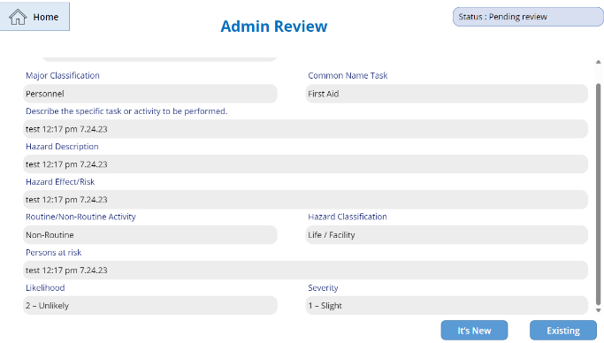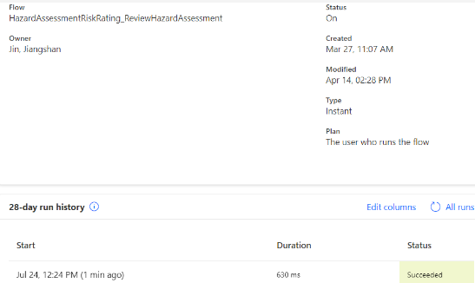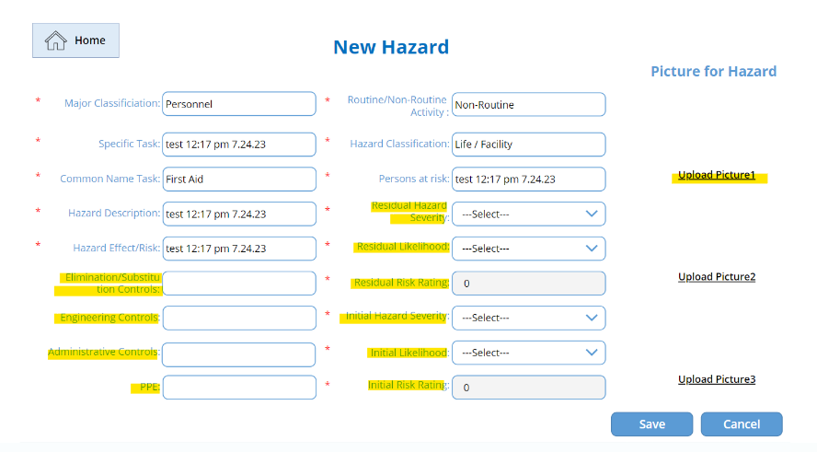

* + After clicking “Save button”, the form should be submitted and the new hazard should be added at the Hazard List.

* **Viewing Dashboard**
  + As a User and/or Admin, I can view all necessary information in the dashboard.

* **Download Hazard Identification Risk Reduction and Controls (HIRRAC) file.**
  + In Hazard List Page, locate and click the “Download” button.

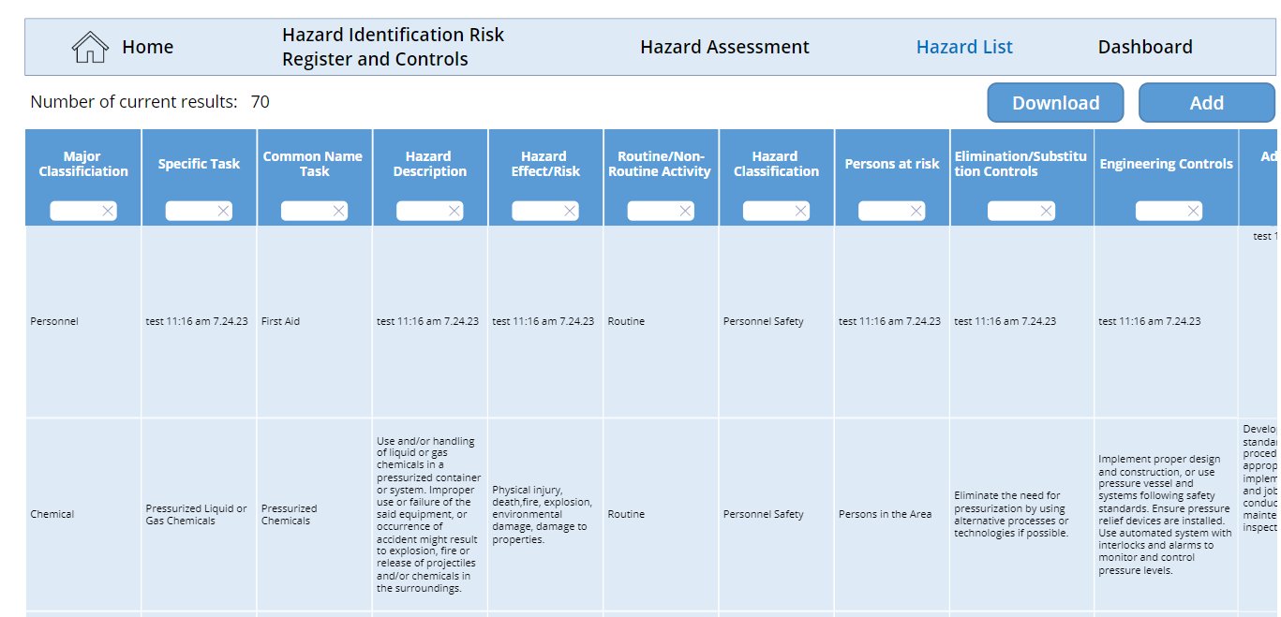

* + After clicking “Download” button, an excel file of Hazard List should be added in OneDrive.

# Application & Functional Architecture

* 1. Application Architecture Overview

The application uses the following technologies:

* + PowerApps
  + Power Automate
  + SharePoint List
  1. Application Flow Diagram

Provided below is the application process flow diagram:

# Infrastructure – Hardware / Software

* 1. Hardware

N/A

* 1. Software

|  |  |  |
| --- | --- | --- |
| **Software** | **Essential** | **Purpose** |
| PowerApps App | [Hazard Assessment and Risk Register - PowerApps](https://apps.powerapps.com/play/e/default-e0793d39-0939-496d-b129-198edd916feb/a/8f59702d-93f3-48e8-a341-dc37a5951344?tenantId=e0793d39-0939-496d-b129-198edd916feb) | Application URL link. |
| HazardAssessmentRiskRating_UserType Flow | [Manage your flows | Power Automate](https://make.powerautomate.com/environments/Default-e0793d39-0939-496d-b129-198edd916feb/flows/shared/b431108a-9385-4218-9cd7-db961958d7b9/details) | Power Automate flow for validating user type. |
| HazardAssessmentRiskRating_ReviewHazardAssessment Flow | [Manage your flows | Power Automate](https://make.powerautomate.com/environments/Default-e0793d39-0939-496d-b129-198edd916feb/flows/shared/95c71fe3-15d5-4c37-8153-2b4e97630429/details) | Power Automate flow for validating the hazard whether its new or existing hazard. |
| HazardAssessmentRiskRating_SubmitHazardAssessment Flow | [Manage your flows | Power Automate](https://make.powerautomate.com/environments/Default-e0793d39-0939-496d-b129-198edd916feb/flows/shared/6d83a2d6-c691-44b4-a10c-495fc3c8b65e/details) | Power Automate flow for sending email notification to the admin team for hazard review. |
| downloadExcel Flow | [Manage your flows | Power Automate](https://make.powerautomate.com/environments/Default-e0793d39-0939-496d-b129-198edd916feb/flows/shared/c2f7f826-aa79-49a0-949d-e5039c481f5f/details) | Power Automate flow for downloading the existing HIRRAC data to OneDrive in Excel file format. |

# Data Architecture

* 1. Data Architecture Overview

The data for this application was stored and managed in SharePoint List.

* 1. Data Flow Diagrams

N/A

* 1. Database List

The application uses SharePoint List as a data source, see below:

T_Base_AdminUserList: [GCHazardAssessment - T_Base_AdminUserList - All Items (accenture.com)](https://ts.accenture.com/sites/GCHazardAssessment/Lists/T_Base_AdminUserList/AllItems.aspx)

T_Business_HazardAssessmentRequest: [GCHazardAssessment - T_Business_HazardAssessmentRequest - All Items (accenture.com)](https://ts.accenture.com/sites/GCHazardAssessment/Lists/T_Business_HazardAssessmentRequest/AllItems.aspx)

T_Base_HazardList: [GCHazardAssessment - T_Base_HazardList - All Items (accenture.com)](https://ts.accenture.com/sites/GCHazardAssessment/Lists/T_Base_HazardList/AllItems.aspx)

* 1. List of Detailed Database Documentation

N/A

# Design Documents (HLD / LLD)

N/A

# Technical Environment

* 1. Technical Environment Overview

N/A

* 1. List of interfaces

N/A

* 1. Error & Exception Handling

N/A

* 1. List of Detailed Technical Documentation

N/A

# Application Maintenance Process & Procedures

* 1. Development Methodology Overview

N/A

* 1. In-Flight and Planned Project Details

N/A

* 1. Maintenance & Enhancement Methodology Overview

N/A

* 1. Templates

N/A

# Application Overview

* The application overview of Hazard Assessment Risk Register App purpose is to collect and manage hazards information with its corresponding necessary controls. A user can report a hazard around their workplace environment where they can log a specific hazard. Also, the admin user can review the submitted hazard and recommend necessary controls to eliminate and/or minimize the hazard.
  1. Ownership & Key Contacts
* [mark.noel.o.delica@accenture.com](mailto:mark.noel.o.delica@accenture.com)
* maycell.t.see.bok@accenture.com
  1. Hours of Operation

N/A

* 1. Application History

N/A

* 1. Application Audit History

N/A

* 1. Restore / Recovery Tests

N/A

# Overview of Interfaces and Interfacing Applications

* 1. External Interfaces (to 3rd Parties)

N/A

* 1. Interfaces to systems operated by other departments.

N/A

* 1. Internal Interface

N/A

* 1. Software Used – Versions & Licenses

N/A

# User Management

* 1. Technical Users
* [mark.noel.o.delica@accenture.com](mailto:mark.noel.o.delica@accenture.com)
* [faye.e.mendoza@accenture.com](mailto:faye.e.mendoza@accenture.com)
* [ricardo.piquero.jr@accenture.com](mailto:ricardo.piquero.jr@accenture.com)
* [winston.a.sarra@accenture.com](mailto:winston.a.sarra@accenture.com)
* maycell.t.see.bok@accenture.com
  1. Personal Accounts for Application Users

1. Link: [Group Web Administration | Search for Group(s) (accenture.com)](https://directory.accenture.com/WebAdmin/search.aspx)

* HazardAssessmentRiskRatingApplication_DevGroup
* HazardAssessmentRiskRatingApplication_UserGroup

# Backup and Recovery

* 1. Backup, Restore & Recoverability Requirements
* HARR back-up URL copy: [Power Apps](https://make.powerapps.com/e/Default-e0793d39-0939-496d-b129-198edd916feb/canvas/?action=edit&app-id=%2Fproviders%2FMicrosoft.PowerApps%2Fapps%2F7079faf9-1f97-4072-b9e8-60094d6ea457)
* Flows:
  + HazardAssessmentRiskRating_SubmitHazardAssessment – Dev: [Manage your flows | Power Automate](https://make.powerautomate.com/environments/Default-e0793d39-0939-496d-b129-198edd916feb/flows/0180fd50-0ca9-485c-b90b-ad4796b1b3a2/details)
  + HazardAssessmentRiskRating_ReviewHazardAssessment – Dev: [Manage your flows | Power Automate](https://make.powerautomate.com/environments/Default-e0793d39-0939-496d-b129-198edd916feb/flows/a50f0386-4762-4669-ae33-7c713cd60df5/details)
  + HazardAssessmentRiskRating_UserType – Dev: [Manage your flows | Power Automate](https://make.powerautomate.com/environments/Default-e0793d39-0939-496d-b129-198edd916feb/flows/0f0b4caa-2a58-4f72-9a37-239a2a88396a/details)
  + downloadExcel – Dev: [Manage your flows | Power Automate](https://make.powerautomate.com/environments/Default-e0793d39-0939-496d-b129-198edd916feb/flows/4918c5d4-680b-4dd5-b5b2-e432274ea58f/details)
  1. Conceptual Explanation & Description

N/A

* 1. Restore & Recovery Instructions

N/A

* 1. Backup Schedule

N/A

* + 1. Scheduling Constraints

N/A

* + 1. Schedule

N/A

* + 1. Permanent Background Processes & Scheduling for Jobs including Interfaces

N/A

* + 1. Shutdown & Startup / Planned Outages & Changes

N/A

* 1. Maintenance Window
     1. Organisation of a Shutdown / Planned Outage of this Application

N/A

* + 1. Impact of a Shutdown of this Application

N/A

* + 1. Impact of an Outage of an Interfacing System on this application

N/A

* + 1. Checklist for a Planned Outage

N/A

* 1. Daily, Weekly, Monthly, and other Regular Duties

N/A

* 1. Monitoring, Troubleshooting, Escalation
     1. Monitoring Steps

N/A

* + 1. Error Messages / common Points of Failure

N/A

* + 1. Resolutions Available and Limitations

N/A

* + 1. Known Errors with Application

N/A

* + 1. KPIs, OLAs & SLAs

N/A

* 1. Known Limitations

N/A

# Data Maintenance

* 1. Maintenance Jobs

N/A

* 1. DB Monitoring

N/A

* 1. Database List

|  |  |  |
| --- | --- | --- |
| **Environment** | **Database Name** | **Schema** |
|  |  |  |
|  |  |  |

* 1. List Key Database / Data File Objects

**Production:**

|  |  |  |
| --- | --- | --- |
| **Environment** | **Database Name** | **Schema** |
|  |  |  |

**Test:**

|  |  |  |
| --- | --- | --- |
| **Environment** | **Database Name** | **Schema** |
| Test |  |  |

# Release Management

N/A

# Deployment

N/A

# Appendix

* 1. Incident, Defect, Problem Log

N/A

* 1. Audio Recordings
* Recording_1: <https://myoffice.accenture.com/:v:/g/personal/jo_ann_o_alinson_accenture_com/ETXJWo-4FF5FvxLSSQGMmc4BFGXHCOLoAmSYqsWcv09RJQ>
* Recording_2: <https://myoffice.accenture.com/:v:/g/personal/jo_ann_o_alinson_accenture_com/EW-HcR0OF4xCmrTqfNz4wbMBH5EgB54pTEILTP21PE7P7A>
* Recording_3:
* <https://myoffice.accenture.com/:v:/g/personal/jo_ann_o_alinson_accenture_com/Ef_LJ_5xibtMkwYpB_U4530BK_dgd5vyOxYCB6HvR1n8wA>
  1. Documentation

Refer here: [Power Apps PODS - Hazard Assessment and Risk Register - All Documents (accenture.com)](https://ts.accenture.com/sites/PowerPaps/Shared%20Documents/Forms/AllItems.aspx?id=%2Fsites%2FPowerPaps%2FShared%20Documents%2FDev%20Support%2FHazard%20Assessment%20and%20Risk%20Register&viewid=bd318e59%2Daec6%2D458c%2Db5c7%2D25be1feb2a08)

# Q&A log

|  |  |  |  |  |  |
| --- | --- | --- | --- | --- | --- |
| Date | KT Task | Question | Asked By - KR | SMA Answer/Clarification | Status |
|  |  |  |  |  |  |
|  |  |  |  |  | OPEN |
|  |  |  |  |  | CLOSED |
|  |  |  |  |  | IN PROGRESS |
|  |  |  |  |  |  |
|  |  |  |  |  |  |
|  |  |  |  |  |  |
|  |  |  |  |  |  |
|  |  |  |  |  |  |
|  |  |  |  |  |  |
|  |  |  |  |  |  |
|  |  |  |  |  |  |
|  |  |  |  |  |  |
|  |  |  |  |  |  |
|  |  |  |  |  |  |
|  |  |  |  |  |  |
|  |  |  |  |  |  |
|  |  |  |  |  |  |
|  |  |  |  |  |  |
|  |  |  |  |  |  |
|  |  |  |  |  |  |
|  |  |  |  |  |  |
|  |  |  |  |  |  |
|  |  |  |  |  |  |
|  |  |  |  |  |  |
|  |  |  |  |  |  |
|  |  |  |  |  |  |
|  |  |  |  |  |  |